Power BI Report Technical Documentation Template
1. Report Overview
- Report Name: IAM Ops Management Dashboard
- Business Owner: Susie Barett, Erica Garcia
- Created By: Sri Vinay Reddy Surabi
- Purpose / Description:
- Target Audience:
2. Data Sources
- Source System(s): vw_SN_sc_Escalation_IamOps_Dashboard
- Connection Type (DirectQuery / Import / Live Connection): Import
- Database Name / Server Name: ServicePerf_DW database
- Tables / Views Used: 1
- Data Gateway Used (if applicable): No
- Credentials / Authentication Method: username: IAM_ServiceNow_Tableau
Password: iamrocks!!
3. Data Model
- Fact Tables: 1
- Dimension Tables:
- Relationships:
- Data Volume / Size: 19.7 M rows
- Data Refresh Frequency: Daily
4. KPIs and Metrics
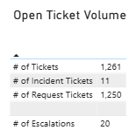

# of Tickets: Count of Ticket numbers by open date – (1)
CALCULATE(COUNT(OpenServiceNow[Ticket Number]),USERELATIONSHIP('Date'[Date],OpenServiceNow[Open Date]))
# of Incident Tickets: Count of Incident type Tickets – (2)
CALCULATE(DISTINCTCOUNT(OpenServiceNow[Incident Tickets]),OpenServiceNow[Incident Tickets] <> BLANK(),USERELATIONSHIP('Date'[Date],OpenServiceNow[Open Date]))
Incident Tickets = IF(OpenServiceNow[Ticket Type] = "Incident",OpenServiceNow[Ticket Number],BLANK())
# of Request Tickets: Count of Request type Tickets – (3)
CALCULATE(DISTINCTCOUNT(OpenServiceNow[Request Tickets]),OpenServiceNow[Request Tickets] <> BLANK(),USERELATIONSHIP('Date'[Date],OpenServiceNow[Open Date]))
Request Tickets = IF(OpenServiceNow[Ticket Type] = "sc_task",OpenServiceNow[Ticket Number],BLANK())
# of Escalations: Counting Escalations tickets where Escalation date is > 01/01/1900 – (4)
CALCULATE(SUM(OpenServiceNow[# of Escalation]),OpenServiceNow[# of Escalation] <> BLANK(),USERELATIONSHIP('Date'[Date],OpenServiceNow[Escalation Date]))
# of Escalation = IF(OpenServiceNow[Date - Service Desk Escalation] > DATE(1900,01,01), 1, BLANK())
On the above visual (Open Ticket Volume) applying the filter status(groups) where it is Open.
Status(group) column is a calculated column based on Status column. Below are the grouping values.
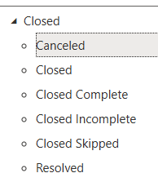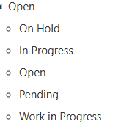
**********************************************************************************************
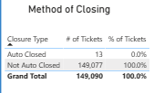
Closure Type: it is derived from Ticket short description and Request Item Category, and it contains Auto closed and Not Auto closed. – ()
Closure Type =
IF(CONTAINSSTRING([Ticket Short Description], "AutoClose"), "Auto Closed",
IF(CONTAINSSTRING([Request Item Category], "IdentityIQ Automated Joiner"), "Auto Closed",
IF(CONTAINSSTRING([Request Item Category], "IdentityIQ Automated Mover"), "Auto Closed",
IF(CONTAINSSTRING([Request Item Category], "IdentityIQ Automated Leaver"), "Auto Closed","Not Auto Closed"
))))
# of Tickets: Distinct count of Ticket Number - (6)
DISTINCTCOUNT(OpenServiceNow[Ticket Number])
% of Tickets: calculating Percentage of tickets by closure type – (7)
VAR A = DISTINCTCOUNT(OpenServiceNow[Ticket Number])
VAR B = CALCULATE(DISTINCTCOUNT(OpenServiceNow[Ticket Number]),ALL(OpenServiceNow[Closure Type]))
RETURN
DIVIDE(A,B)
The filter applied on this visual is status(group) closed. **********************************************************************************************
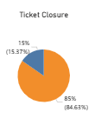
We are showcasing Ticket Closures by various time intervals from 1-14 days SLT
(8) - Dynamic Ticket % =
VAR SelectedSLT = SELECTEDVALUE ( 'SLT in Days'[SLT in Days], 7 )
VAR BaseLabel = SELECTEDVALUE ( 'Legend Base'[Base] )
VAR TotalTickets = CALCULATE ( DISTINCTCOUNT ( OpenServiceNow[Ticket Number] ) )
VAR TicketCount = SWITCH (TRUE (),
BaseLabel = "<=",
CALCULATE (
DISTINCTCOUNT ( OpenServiceNow[Ticket Number] ),
FILTER ( OpenServiceNow, OpenServiceNow[TicketAge.Days] <= SelectedSLT )),
BaseLabel = ">",
CALCULATE (
DISTINCTCOUNT ( OpenServiceNow[Ticket Number] ),
FILTER ( OpenServiceNow, OpenServiceNow[TicketAge.Days] > SelectedSLT )))
RETURN DIVIDE ( TicketCount,TotalTickets )
- SLT in Days: it is a calculated table and below is the DAX logic – (9)
SLT in Days = GENERATESERIES(1, 14, 1) –

- Legend Base: it is a calucated table and below is the DAX logic – (10)
Legend Base = DATATABLE("Base", STRING, { {"<="}, {">"} }) –

- TicketAge.Days: it is a calculated column created in OpenServiceNow table and below is the DAX logic – (11)
TicketAge.Days = IF(ISBLANK(OpenServiceNow[Resolved Date]), DATEDIFF(OpenServiceNow[Date - Task Opened],TODAY(),DAY),DATEDIFF(OpenServiceNow[Date - Task Opened],OpenServiceNow[Resolved Date],DAY))
- Resolved Date: it is a calculated column created in OpenServiceNow table and below is the DAX logic – (12)
IF(OpenServiceNow[System2.SNow] = "ServiceNow" && OpenServiceNow[Ticket Type] = "sc_task" && OpenServiceNow[Status (groups)] = "Closed", [Date - Closed],
IF(OpenServiceNow[System2.SNow] = "ServiceNow" && OpenServiceNow[Ticket Type] = "sc_req_item" && OpenServiceNow[Status (groups)] = "Closed", [Date - Closed],
IF(OpenServiceNow[System2.SNow] = "ServiceNow" && OpenServiceNow[Ticket Type] = "incident" && OpenServiceNow[Status (groups)] = "Closed", [Date - Resolved],BLANK())))
The visual (Ticket closure) is using the Date table filter where year is 2023, 2024, and 2025.

Date is a calculated dimension table and below is the Dax logic - (13)

VAR A = MINX(OpenServiceNow,OpenServiceNow[Open Date])
VAR B = MINX(OpenServiceNow,OpenServiceNow[Resolved Date 2])
VAR C = IF(A<B,A,B)
VAR D = MAXX(OpenServiceNow,OpenServiceNow[Open Date])
VAR E = MAXX(OpenServiceNow,OpenServiceNow[Resolved Date 2])
VAR F = IF(D>E,D,E)
RETURN
CALENDAR(C,F)

- Open Date: It is derived from Date – Task Opened column from OpenServiceNow table – (14)
Open Date = DATE(YEAR(OpenServiceNow[Date - Task Opened]),MONTH(OpenServiceNow[Date - Task Opened]),DAY(OpenServiceNow[Date - Task Opened]))
- Resolved Date 2: it is derived from Resolved Date column from the OpenServiceNow table – (15)
Resolved Date 2 = DATE(YEAR([Resolved Date]),MONTH(OpenServiceNow[Resolved Date]),DAY(OpenServiceNow[Resolved Date]))

******************************************************************************************
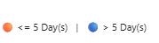

The above visual acts like legend to identify number of SLT Days according to the slicer selection. Below is logic - (16)

VAR SelectedSLT =
SELECTEDVALUE ( 'SLT in Days'[SLT in Days] )
VAR OrangeIcon = UNICHAR(128992) /
VAR BlueIcon = UNICHAR(128309)
RETURN
IF (
NOT ISBLANK ( SelectedSLT ),
// First Label (Orange)
OrangeIcon & " " & "<= " & FORMAT ( SelectedSLT, "0" ) & " Day(s)" &
" | " &
// Second Label (Blue)
BlueIcon & " " & "> " & FORMAT ( SelectedSLT, "0" ) & " Day(s)",
"Select SLT Days"
)

******************************************************************************************
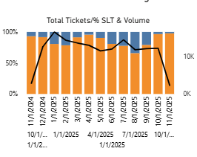
We are showcasing volume of tickets by different SLT’s and dates

Date Detail 2: it is a parameter table created for dynamic X-axis. – (17)
Date Detail 2 = {
("Year", NAMEOF('Date'[Year]), 0),
("Quarter", NAMEOF('Date'[Quarter]), 1),
("Month", NAMEOF('Date'[Month]), 2),
("Week", NAMEOF('Date'[Week]), 3),
("Day", NAMEOF('Date'[Date]), 4)
}
Considering Date refer to (13) from Date table also in the X – axis to get hierarchical structure
Using the Dynamic Ticket % refer to (8) in the Y – Axis
Dynamic Ticket Count: Distinct count of Ticket Number – (18)
Dynamic Ticket Count = CALCULATE(DISTINCTCOUNT(OpenServiceNow[Ticket Number]))
Using the Legend base table refer to (10) in the Legend section
Applying the Date column from Date table in this visual where we are using the Year 2023,2024, and 2025.
**********************************************************************************************
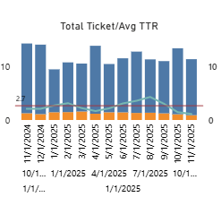

We are showcasing Total Ticket and Average TTR across different timelines and SLT’s
We are considering Date Detail table and Date table in the X-axis
Avg TTR by SLT: calculating average of Ticket.age Days column - (19)
VAR SelectedSLT =
SELECTEDVALUE ( 'SLT in Days'[SLT in Days], 7 )
VAR BaseLabel =
SELECTEDVALUE ( 'Legend Base'[Base] )
VAR AvgTTR =
SWITCH (
TRUE (),
BaseLabel = "<=",
CALCULATE (
AVERAGE ( OpenServiceNow[TicketAge.Days] ),
FILTER ( OpenServiceNow, OpenServiceNow[TicketAge.Days] <= SelectedSLT )
),
BaseLabel = ">",
CALCULATE (
AVERAGE ( OpenServiceNow[TicketAge.Days] ),
FILTER ( OpenServiceNow, OpenServiceNow[TicketAge.Days] > SelectedSLT )))
RETURN AvgTTR
Considering Average of TTR. Days in the visual as Y – Axis constant Line
TTR. Days: it is a calculated column from OpenServiceNow table. The below is DAX logic – (20)
TTR.Days = IF(ISBLANK(OpenServiceNow[Resolved Date]),BLANK(),DATEDIFF(OpenServiceNow[Date - Task Opened],OpenServiceNow[Resolved Date],DAY))
We are considering the Average of TTR. Days in the Y- Axis
Considering the Legend Base table for the legend section
In filter pane we are using the Date table where we are considering the year 2023, 2024, and 2025
**********************************************************************************************
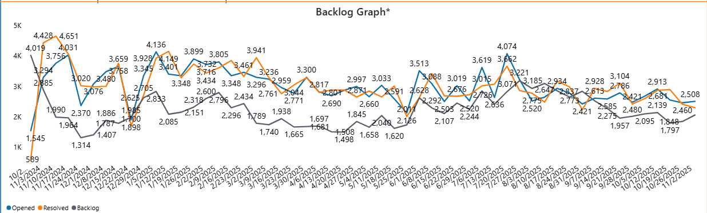
We are showcasing Opened, Resolved, and Backlog Tickets across various timelines like day, week, Month, Quarter and Year.
We are using Date Detail column from the Date Detail 2 Table refer (17) in the X – Axis
We are using three measures in the Y – axis
Opened: Count of Tickets that are opened on respective date – (21)
Opened_Backlog =
CALCULATE(
COUNT('OpenServiceNow'[Ticket Number]),
USERELATIONSHIP('Date'[Date], 'OpenServiceNow'[Open Date])
)
Resolved: Count of Tickets that are resolved on respective date – (22)
Resolved_Backlog =
VAR CurrDate = MAX('Date'[Date])
RETURN
CALCULATE(DISTINCTCOUNT(OpenServiceNow[Ticket Number]))
Backlog: Count of Tickets that are in Backlog on respective date – (23)
!Backlog_2 =
VAR CurrDate = MAX('Date'[Date])
VAR OpenedTillDate =
CALCULATE(
COUNT('OpenServiceNow'[Ticket Number]),
USERELATIONSHIP('Date'[Date], 'OpenServiceNow'[Open Date]),
FILTER(ALL('Date'), 'Date'[Date] <= CurrDate)
)
VAR ClosedTillDate =
CALCULATE(
DISTINCTCOUNT('OpenServiceNow'[Ticket Number]),
FILTER(
ALL('OpenServiceNow'),
NOT(ISBLANK('OpenServiceNow'[!Date - Resolved])) &&
'OpenServiceNow'[!Date - Resolved] <= CurrDate
)
)
RETURN
COALESCE(OpenedTillDate - ClosedTillDate, 0)
The filter applied for this visual is Date column from Date table which is not blank.
**********************************************************************************************
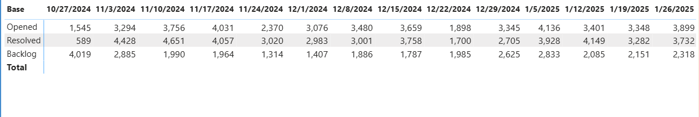
We are showcasing Opened, Resolved, and Backlog Tickets across various timelines like day, week, Month, Quarter and Year in table format.
We are considering Backlog table Base column in Rows – (24)
Backlog Table = DATATABLE("Base", STRING,"Sort",INTEGER, { {"Opened",1}, {"Resolved",2},{"Backlog",3}})
We are considering Date Detail 2 table for the column section
We are considering Backlog tlb measure in the values section – (25)
Backlog tlb measure = IF(HASONEVALUE('Backlog Table'[Base]),SWITCH(SELECTEDVALUE('Backlog Table'[Base]),"Opened",[Opened_Backlog],"Resolved",[Resolved_Backlog],"Backlog",[!Backlog_2]))
For this visual we are using the System2.Snow filter where are considering the values as not blank
**********************************************************************************************
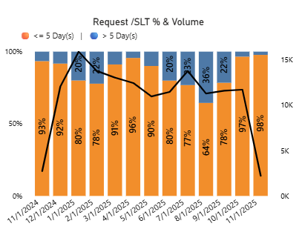
This visual is showcasing Request tickets percentages and number of tickets closed across multiple SLT days and timelines like years, Quarters, month, weeks, and days
We are considering Date Detail 2 table and Date table in the X – axis
We are considering Dynamic ticket % refer (8) in Y – axis
We are considering Dynamic Ticket Count refer (18) in the Line y- axis
In the legend section we are considering Legend Base table
We are applying Ticket Type as sc_task as filter for this visual
We are applying the Date table on this visual as filter and selecting year 2023, 2024, and 2025.
**********************************************************************************************
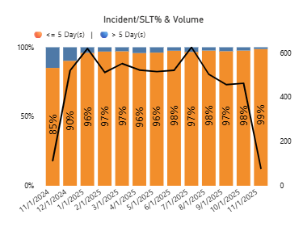
This visual is showcasing Incident tickets percentages and number of tickets closed across multiple SLT days and timelines like years, Quarters, month, weeks, and days
We are considering Date Detail 2 table and Date table in the X – axis
We are considering Dynamic ticket % in Y – axis
We are considering Dynamic Ticket Count in the Line y- axis
In the legend section we are considering Legend Base table
We are applying Ticket Type as Incident as filter for this visual
We are applying the Date table on this visual as filter and selecting year 2023, 2024, and 2025.
**********************************************************************************************
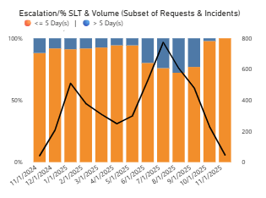
This visual is showcasing Escalation tickets percentages and number of tickets across multiple SLT days and timelines like years, Quarters, month, weeks, and days
We are considering Date Detail 2 table and Date table in the X – axis
We are considering Dynamic ticket % in Y – axis
We are considering Dynamic Ticket Count in the Line y- axis
In the legend section we are considering Legend Base table
We are applying Is Escalation as Yes as filter for this visual – (26)
Is Escalation = IF(OpenServiceNow[Date - Service Desk Escalation] > DATE(1900,01,01),"Yes","No")
We are applying Assignment Queues as PHS as filter for this visual – (27)
Assignment Queues = IF(CONTAINSSTRING(OpenServiceNow[Assigned to Group],"SJH"),"SJH", IF(CONTAINSSTRING(OpenServiceNow[Assigned to Group],"Infosys"),"Infosys",
"PHS"))
We are applying the Date table on this visual as filter and selecting year 2023, 2024, and 2025.
**********************************************************************************************
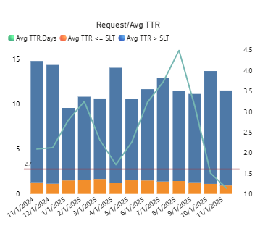
We are showcasing average of Ticket age Days, average of TTR Days for Request, and average of TTR Days in Y- Axis constant line across multiple SLT days and timeline like Years, Quarters, Months, Week, and Days.
We are considering Date Detail 2 and Date table in X – axis
We are considering Avg TTR by SLT refer (19) in y – axis
We are considering average of TTR Days refer (20) in line y – axis
In the legend section we are considering Legend Base table
We are applying Ticket Type as sc_task as filter for this visual
We are applying the Date table on this visual as filter and selecting year 2023, 2024, and 2025.
**********************************************************************************************
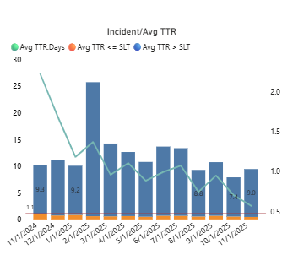
We are showcasing average of Ticket age Days, average of TTR Days for Incident, and average of TTR Days in Y- Axis constant line across multiple SLT days and timeline like Years, Quarters, Months, Week, and Days.
We are considering Date Detail 2 and Date table in X – axis
We are considering Avg TTR by SLT refer (19) in y – axis
We are considering average of TTR Days refer(20) in line y – axis
In the legend section we are considering Legend Base table
We are applying Ticket Type as Incident as filter for this visual
We are applying the Date table on this visual as filter and selecting year 2023, 2024, and 2025.
**********************************************************************************************
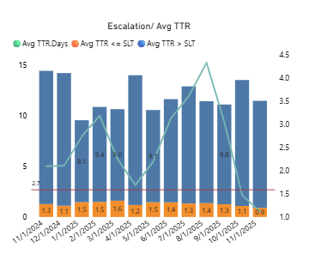
We are showcasing average of Ticket age Days, average of TTR Days for Escalations, and average of TTR Days in Y- Axis constant line across multiple SLT days and timeline like Years, Quarters, Months, Week, and Days.
We are considering Date Detail 2 and Date table in X – axis
We are considering Avg TTR by SLT in y – axis
We are considering average of TTR Days in line y – axis
In the legend section we are considering Legend Base table
We are applying Is Escalation as Yes as filter for this visual
We are applying the Date table on this visual as filter and selecting year 2023, 2024, and 2025.
**********************************************************************************************
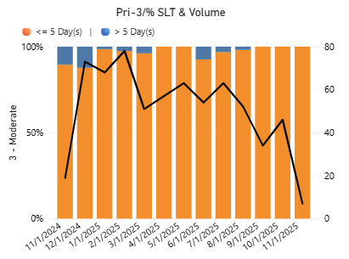
This visual is showcasing Priority 3 -moderate tickets percentages and number of tickets closed across multiple SLT days and timelines like years, Quarters, month, weeks, and days
We are considering Date Detail 2 table in the X – axis
We are considering Dynamic ticket % refer (8) in Y – axis
We are considering Dynamic Ticket Count refer (18) in the Line y- axis
In the legend section we are considering Legend Base table
We are applying Ticket Type as Incident as filter for this visual
We are applying New Priority a calculated column from OpenServiceNow table as 3- moderate to this visual. – (28)
New_Priority =
IF(OpenServiceNow [Priority] = "3 - Moderate", [Priority],
IF(OpenServiceNow [Priority] = "4 - Low", [Priority],
IF(OpenServiceNow [Priority] = "5 - Planning", [Priority],"5 - Planning")))
We are applying the Date table on this visual as filter and selecting year 2023, 2024, and 2025.
**********************************************************************************************
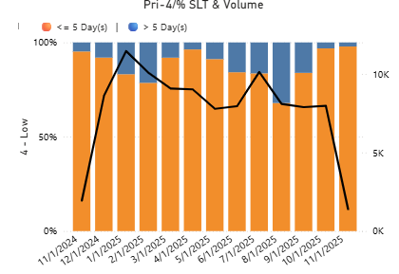
This visual is showcasing Priority 4 – Low tickets percentages and number of tickets closed across multiple SLT days and timelines like years, Quarters, month, weeks, and days
We are considering Date Detail 2 table in the X – axis
We are considering Dynamic ticket % refer (8) in Y – axis
We are considering Dynamic Ticket Count refer (18) in the Line y- axis
In the legend section we are considering Legend Base table
We are applying Ticket Type as Incident as filter for this visual
We are applying New Priority refer (28) a calculated column from OpenServiceNow table as 4- low to this visual.
We are applying the Date table on this visual as filter and selecting year 2023, 2024, and 2025.
**********************************************************************************************
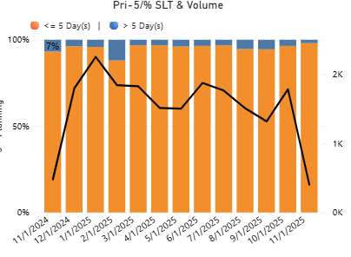
This visual is showcasing Priority 5 – Planning tickets percentages and number of tickets closed across multiple SLT days and timelines like years, Quarters, month, weeks, and days
We are considering Date Detail 2 table in the X – axis
We are considering Dynamic ticket % refer (8) in Y – axis
We are considering Dynamic Ticket Count refer (18) in the Line y- axis
In the legend section we are considering Legend Base table
We are applying Ticket Type as Incident as filter for this visual
We are applying New Priority a calculated column from OpenServiceNow table as 5-Planning to this visual.
We are applying the Date table on this visual as filter and selecting year 2023, 2024, and 2025.
**********************************************************************************************
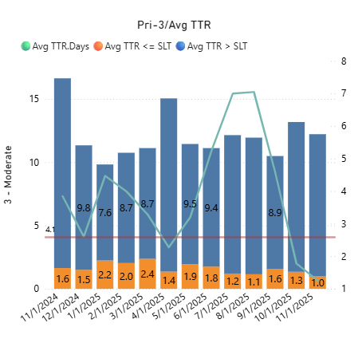
We are showcasing average of Ticket age Days, average of TTR Days for Priority 3 – moderate tickets, and average of TTR Days in Y- Axis constant line across multiple SLT days and timeline like Years, Quarters, Months, Week, and Days.
We are considering Date Detail 2 and Date table in X – axis
We are considering Avg TTR by SLT refer (19) in y – axis
We are considering average of TTR Days refer(20) in line y – axis
In the legend section we are considering Legend Base table
We are applying Ticket Type as Incident as filter for this visual
We are applying New Priority a calculated column from OpenServiceNow table as 3 – moderate to this visual.
We are applying the Date table on this visual as filter and selecting year 2023, 2024, and 2025.
**********************************************************************************************

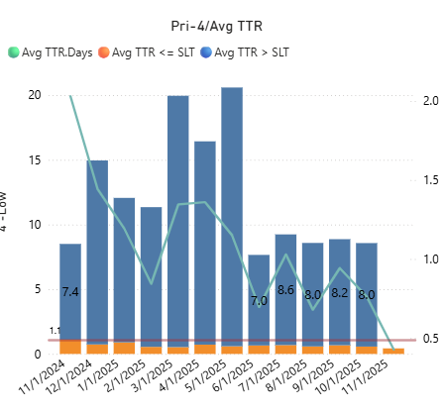
We are showcasing average of Ticket age Days, average of TTR Days for Priority 4 – Low tickets, and average of TTR Days in Y- Axis constant line across multiple SLT days and timeline like Years, Quarters, Months, Week, and Days.
We are considering Date Detail 2 and Date table in X – axis
We are considering Avg TTR by SLT in y – axis
We are considering average of TTR Days in line y – axis
In the legend section we are considering Legend Base table
We are applying Ticket Type as Incident as filter for this visual
We are applying New Priority a calculated column from OpenServiceNow table as 4 – Low to this visual.
We are applying the Date table on this visual as filter and selecting year 2023, 2024, and 2025.
**********************************************************************************************
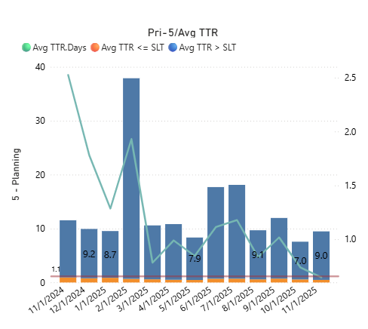
We are showcasing average of Ticket age Days, average of TTR Days for Priority 5 – Planning tickets, and average of TTR Days in Y- Axis constant line across multiple SLT days and timeline like Years, Quarters, Months, Week, and Days.
We are considering Date Detail 2 and Date table in X – axis
We are considering Avg TTR by SLT in y – axis
We are considering average of TTR Days in line y – axis
In the legend section we are considering Legend Base table
We are applying Ticket Type as Incident as filter for this visual
We are applying New Priority a calculated column from OpenServiceNow table as 5- Planning to this visual.
We are applying the Date table on this visual as filter and selecting year 2023, 2024, and 2025.
**********************************************************************************************
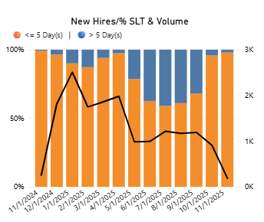
This visual is showcasing New Hires (New Caregiver Onboarding) tickets percentages and number of tickets closed across multiple SLT days and timelines like years, Quarters, month, weeks, and days
We are considering Date Detail 2 table in the X – axis
We are considering Dynamic ticket % in Y – axis
We are considering Dynamic Ticket Count in the Line y- axis
In the legend section we are considering Legend Base table
We are applying Request Area. Caregivers which is a calculated column from OpenServiceNow table and selecting New Caregiver Onboarding in the filter pane. – (29)
Request Area.Caregivers =
SWITCH (
TRUE (),
'OpenServiceNow'[System2.SNow] = "ServiceNow"
&& CONTAINSSTRING ( 'OpenServiceNow'[Request Area], "SailPoint Term" ),
"SailPoint Termination",
'OpenServiceNow'[System2.SNow] = "ServiceNow"
&& CONTAINSSTRING ( 'OpenServiceNow'[Request Area], "Termination" ),
"Non-SailPoint Termination",
'OpenServiceNow'[Request Item Category] = "IdentityIQ Automated Leaver",
"SailPoint Termination",
'OpenServiceNow'[Ticket Type] = "sc_task"
&& CONTAINSSTRING ( 'OpenServiceNow'[Ticket Short Description], "Caregiver Identity Creation" ),
"New Caregiver Onboarding",
'OpenServiceNow'[Ticket Type] = "sc_task"
&& CONTAINSSTRING ( 'OpenServiceNow'[Ticket Short Description], "Review Duplicate" ),
"New Caregiver Onboarding",
'OpenServiceNow'[Ticket Type] = "sc_task"
&& CONTAINSSTRING ( 'OpenServiceNow'[Ticket Short Description], "Persona Modification" )
&& CONTAINSSTRING ( 'OpenServiceNow'[Ticket Short Description], "Add" ),
"Existing Caregiver Onboarding",
"Other"
)
Below is how we are calculating Request Area (IAM Work Queues) which is a calculating column in OpenServiceNow table - (30)
Request Area =
IF(OpenServiceNow[Ticket Type] = "sc_task" && CONTAINSSTRING([Request Item Category], "SailPoint Termination"), "SailPoint Termination",
IF(OpenServiceNow[Ticket Type] = "sc_task" && CONTAINSSTRING([Request Item Category], "SailPoint New SJH Registry") && CONTAINSSTRING([Ticket Short Description], "SailPoint Termination"), "SailPoint Termination",
IF(OpenServiceNow[Ticket Type] = "sc_task" && CONTAINSSTRING([Ticket Short Description], "Caregiver Identity Creation"), "SailPoint New Hire",
IF(OpenServiceNow[Ticket Type] = "sc_task" && CONTAINSSTRING([Ticket Short Description], "Duplicate"), "SailPoint Review Duplicate",
IF(OpenServiceNow[Ticket Type] = "sc_task" && CONTAINSSTRING([Request Item Category], "SailPoint Modify Caregiver") && CONTAINSSTRING([Ticket Short Description], "Persona Edit"), "SailPoint Persona Edit",
IF(OpenServiceNow[Ticket Type] = "sc_task" && CONTAINSSTRING([Request Item Category], "SailPoint New SJH Registry") && CONTAINSSTRING([Ticket Short Description], "Persona Edit"), "SailPoint Persona Edit",
IF(OpenServiceNow[Ticket Type] = "sc_task" && CONTAINSSTRING([Ticket Short Description], "Persona Modification") && CONTAINSSTRING([Ticket Short Description], "Add"), "SailPoint Modify Caregiver",
IF(OpenServiceNow[Ticket Type] = "sc_task" && CONTAINSSTRING([Ticket Short Description], "Remote Access"), "Remote Access",
IF(OpenServiceNow[Ticket Type] = "sc_task" && CONTAINSSTRING([Request Ticket Summary], "Remote Access"), "Remote Access",
IF(OpenServiceNow[Ticket Type] = "sc_task" && CONTAINSSTRING([Ticket Short Description], "Grant template"), "PHS Epic Hyperspace",
IF(OpenServiceNow[Ticket Type] = "sc_task" && CONTAINSSTRING([Request Ticket Summary], "EPIC-ORCA"), "PHS Epic Hyperspace",
IF(OpenServiceNow[Ticket Type] = "sc_task" && CONTAINSSTRING([Request Ticket Summary], "EPIC-WAMT"), "PHS Epic Hyperspace",
IF(OpenServiceNow[Ticket Type] = "sc_task" && CONTAINSSTRING([Ticket Short Description], "distribution list or mailbox"), "Shared Mailbox",
IF(OpenServiceNow[Ticket Type] = "sc_task" && CONTAINSSTRING([Ticket Short Description], "shared mailbox"), "Shared Mailbox",
IF(OpenServiceNow[Ticket Type] = "sc_task" && CONTAINSSTRING([Request Ticket Summary], "shared mailbox"), "Shared Mailbox",
IF(OpenServiceNow[Ticket Type] = "sc_task" && CONTAINSSTRING([Ticket Short Description], "DL action to take"), "Distribution List",
IF(OpenServiceNow[Ticket Type] = "sc_task" && CONTAINSSTRING([Request Ticket Summary], "Distribution List"), "Distribution List",
IF(OpenServiceNow[Ticket Type] = "sc_task" && CONTAINSSTRING([Ticket Short Description], "Network Drive Access"), "Network Drive Access",
IF(OpenServiceNow[Ticket Type] = "sc_task" && CONTAINSSTRING([Ticket Short Description], "Mailbox Size Adjustment"), "Exchange.Mailbox Size Adjustment",
IF(OpenServiceNow[Ticket Type] = "sc_task" && CONTAINSSTRING([Ticket Short Description], "Extend network access"), "Access Extension",
IF(OpenServiceNow[Ticket Type] = "sc_task" && CONTAINSSTRING([Request Ticket Summary], "I can't find what I need"), "ICFWIN",
IF(OpenServiceNow[Ticket Type] = "sc_task" && CONTAINSSTRING([Ticket Short Description], "Provision ActiveSync"), "Exchange.ActiveSync",
IF(OpenServiceNow[Ticket Type] = "sc_task" && CONTAINSSTRING([Ticket Short Description], "Enable ActiveSync"), "Exchange.ActiveSync",
IF(OpenServiceNow[Ticket Type] = "sc_task" && CONTAINSSTRING([Ticket Short Description], "Enable Lync"), "Exchange.Lync",
IF(OpenServiceNow[Ticket Type] = "sc_task" && CONTAINSSTRING([Ticket Short Description], "Exchange-PHS"), "Exchange",
IF(OpenServiceNow[Ticket Type] = "sc_task" && CONTAINSSTRING([Ticket Short Description], "Local Admin Rights"), "Local Admin Rights",
IF(OpenServiceNow[Ticket Type] = "sc_task" && CONTAINSSTRING([Ticket Short Description], "Epic Hyperspace-ORCA"), "PHS Epic Hyperspace",
IF(OpenServiceNow[Ticket Type] = "sc_task" && CONTAINSSTRING([Ticket Short Description], "Application Access Request"), "Grant Application Access",
IF(OpenServiceNow[Ticket Type] = "sc_task" && CONTAINSSTRING([Ticket Short Description], "Please provide access to"), "Grant Application Access",
IF(OpenServiceNow[Ticket Type] = "sc_task" && CONTAINSSTRING([Ticket Short Description], "add access"), "Grant Application Access",
IF(OpenServiceNow[Ticket Type] = "sc_task" && CONTAINSSTRING([Ticket Short Description], "access request"), "Grant Application Access",
IF(OpenServiceNow[Ticket Type] = "sc_task" && CONTAINSSTRING([Request Item Ticket Summary], "Please use this request if you cannot find what you are looking for."), "ICFWIN",
IF(OpenServiceNow[Ticket Type] = "sc_task" && CONTAINSSTRING([Request Item Ticket Summary], "Application Access Request"), "Grant Application Access",
IF(OpenServiceNow[Ticket Type] = "sc_task" && CONTAINSSTRING([Ticket Short Description], "Term"), "Termination",
IF(OpenServiceNow[Ticket Type] = "sc_task" && CONTAINSSTRING([Request Ticket Summary], "IS to IS request"), "IS to IS Request",
IF(OpenServiceNow[Ticket Type] = "sc_task" && CONTAINSSTRING([Request Item Ticket Summary], "IS to IS request"), "IS to IS Request",
IF(OpenServiceNow[Ticket Type] = "sc_task" && CONTAINSSTRING([Ticket Short Description], "IS to IAM request"), "IS to IAM Request",
IF(OpenServiceNow[Ticket Type] = "sc_task" && CONTAINSSTRING([Request Item Ticket Summary], "IS to IAM request"), "IS to IAM Request",
IF( OpenServiceNow[System2.SNow] = "ServiceNow" && [Ticket Type] = "Incident", "Incident","Other")))))))))))))))))))))))))))))))))))))))
We are applying the Date table on this visual as filter and selecting year 2023, 2024, and 2025.
**********************************************************************************************

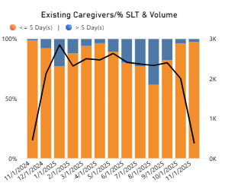
This visual is showcasing Existing Caregivers (Existing Caregiver Onboarding) tickets percentages and number of tickets closed across multiple SLT days and timelines like years, Quarters, month, weeks, and days
We are considering Date Detail 2 table in the X – axis
We are considering Dynamic ticket % in Y – axis
We are considering Dynamic Ticket Count in the Line y- axis
In the legend section we are considering Legend Base table
We are applying Request Area. Caregivers refer (29) which is a calculated column from OpenServiceNow table and selecting Existing Caregiver Onboarding in the filter pane.
We are applying the Date table on this visual as filter and selecting year 2023, 2024, and 2025.
**********************************************************************************************
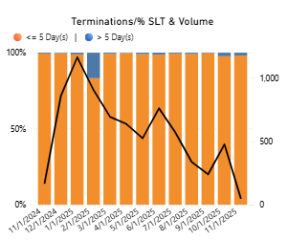
This visual is showcasing Terminations tickets percentages and number of tickets closed across multiple SLT days and timelines like years, Quarters, month, weeks, and days
We are considering Date Detail 2 table in the X – axis
We are considering Dynamic ticket % in Y – axis
We are considering Dynamic Ticket Count in the Line y- axis
In the legend section we are considering Legend Base table
We are applying the Request Area. Caregivers refer (29) which is a calculated column from OpenServiceNow table and selecting Non – SailPoint Termination and SailPoint Termination in the filter pane.
We are applying the Date table on this visual as filter and selecting year 2023, 2024, and 2025.
**********************************************************************************************
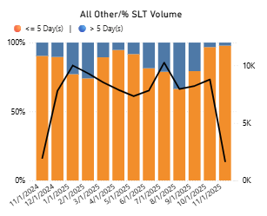
This visual is showcasing All Other tickets percentages and number of tickets closed across multiple SLT days and timelines like years, Quarters, month, weeks, and days
We are considering Date Detail 2 table in the X – axis
We are considering Dynamic ticket % in Y – axis
We are considering Dynamic Ticket Count in the Line y- axis
In the legend section we are considering Legend Base table
We are applying the Request Area. Caregivers refer(29) which is a calculated column from OpenServiceNow table and selecting Other in the filter pane.
We are applying the Date table on this visual as filter and selecting year 2023, 2024, and 2025
**********************************************************************************************
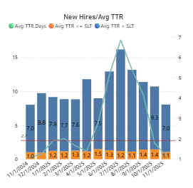
We are showcasing average of Ticket age Days, average of TTR Days for New Hires(New Caregiver Onboarding) tickets, and average of TTR Days in Y- Axis constant line across multiple SLT days and timeline like Years, Quarters, Months, Week, and Days.
We are considering Date Detail 2 and Date table in X – axis
We are considering Avg TTR by SLT in y – axis
We are considering average of TTR Days in line y – axis
In the legend section we are considering Legend Base table
We are applying the Request Area. Caregivers is a calculated column from OpenServiceNow table and selecting New Caregiver Onboarding in the filter pane.
We are applying the Date table on this visual as filter and selecting year 2023, 2024, and 2025.
**********************************************************************************************
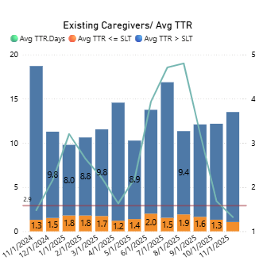
We are showcasing average Ticket age Days, average of TTR Days for Existing Caregivers tickets, and average of TTR Days in Y- Axis constant line across multiple SLT days and timeline like Years, Quarters, Months, Week, and Days.
We are considering Date Detail 2 and Date table in X – axis
We are considering Avg TTR by SLT in y – axis
We are considering average of TTR Days in line y – axis
In the legend section we are considering Legend Base table
We are applying the Request Area. Caregivers is a calculated column from OpenServiceNow table and selecting Existing Caregiver Onboarding in the filter pane.
We are applying the Date table on this visual as filter and selecting year 2023, 2024, and 2025.
**********************************************************************************************
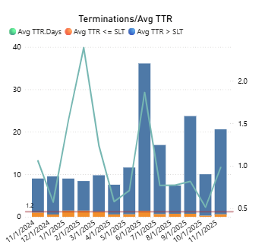
We are showcasing average Ticket age Days, average of TTR Days for Terminations tickets, and average of TTR Days in Y- Axis constant line across multiple SLT days and timeline like Years, Quarters, Months, Week, and Days.
We are considering Date Detail 2 and Date table in X – axis
We are considering Avg TTR by SLT in y – axis
We are considering average of TTR Days in line y – axis
In the legend section we are considering Legend Base table
We are applying the Request Area. Caregivers is a calculated column from OpenServiceNow table and selecting both SailPoint Termination and Non-SailPoint Termination in the filter pane.
We are applying the Date table on this visual as filter and selecting year 2023, 2024, and 2025.
**********************************************************************************************
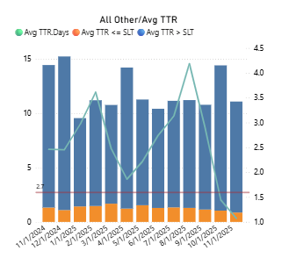
We are showcasing average Ticket age Days, average of TTR Days for All other tickets, and average of TTR Days in Y- Axis constant line across multiple SLT days and timeline like Years, Quarters, Months, Week, and Days.
We are considering Date Detail 2 and Date table in X – axis
We are considering Avg TTR by SLT in y – axis
We are considering average of TTR Days in line y – axis
In the legend section we are considering Legend Base table
We are applying the Request Area. Caregivers is a calculated column from OpenServiceNow table and selecting Other in the filter pane.
We are applying the Date table on this visual as filter and selecting year 2023, 2024, and 2025.
**********************************************************************************************
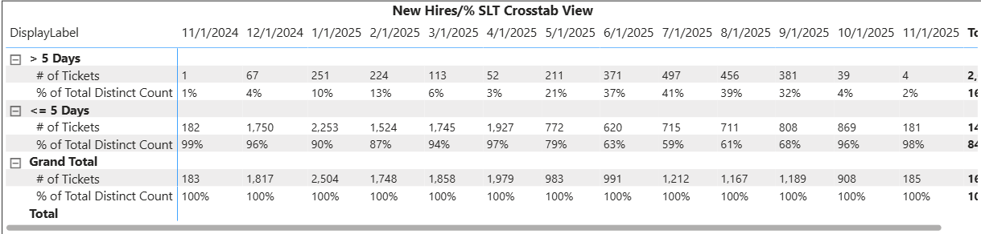
We are showcasing number of Tickets and percentage of Tickets for New Hires (New Caregiver Onboarding) by SLT Days and various timelines like years, Quarters, Months, weeks, Days.
We created dynamic parameters to populate SLT Days values in rows section of matrix table
Below is the calculated table logic – (31)
SLT_Matrix_Display = VAR SLTs = GENERATESERIES(1, 14, 1)
VAR Metrics =
DATATABLE(
"Metric", STRING,
{
{ "# of Tickets" },
{ "% of Total Distinct Count" }
}
)
-- build rows for <= and > groups for every SLT value
VAR LE_GT =
SELECTCOLUMNS(
ADDCOLUMNS(
CROSSJOIN(SLTs, Metrics),
"GroupType", "LE" -- <= group
),
"SLTValue", [Value],
"GroupType", "LE",
"Metric", [Metric]
)
VAR GT =
SELECTCOLUMNS(
ADDCOLUMNS(
CROSSJOIN(SLTs, Metrics),
"GroupType", "GT" -- > group
),
"SLTValue", [Value],
"GroupType", "GT",
"Metric", [Metric]
)
-- Grand total rows (SLTValue blank)
VAR GrandTotal =
SELECTCOLUMNS(
DATATABLE(
"Metric", STRING,
{
{ "# of Tickets" },
{ "% of Total Distinct Count" }
}
),
"SLTValue", BLANK(),
"GroupType", "GTOTAL",
"Metric", [Metric]
)
RETURN
UNION(LE_GT, GT, GrandTotal)
We have created a calculated column called DisplayLabel from SLT_Matrix_Display table. Below is DAX – (32)
DisplayLabel =
VAR v = SLT_Matrix_Display[SLTValue]
VAR gt = SLT_Matrix_Display[GroupType]
RETURN
SWITCH(
TRUE(),
gt = "GTOTAL", "Grand Total",
gt = "LE", "<= " & FORMAT(v, "0") & " Days",
gt = "GT", "> " & FORMAT(v, "0") & " Days",
BLANK())
We are considering the Request Area. Caregivers refer(29) in the filter for this visual and selecting New Caregivers Onboarding
We are applying the Date table on this visual as filter and selecting year 2023, 2024, and 2025.
We are using ShowSLTRow measure in the filter and selecting it as 1. Below is DAX – (32)
ShowSLTRow =
VAR SelectedSLT = SELECTEDVALUE('SLT in Days'[SLT in Days], BLANK())
VAR ThisSLT = MAX( SLT_Matrix_Display[SLTValue] ) -- row SLT value (or blank)
VAR ThisGroup = SELECTEDVALUE( SLT_Matrix_Display[GroupType] )
RETURN
IF(
ThisGroup = "GTOTAL" || ( NOT ISBLANK(SelectedSLT) && ThisSLT = SelectedSLT ),
1,
0
)
**********************************************************************************************

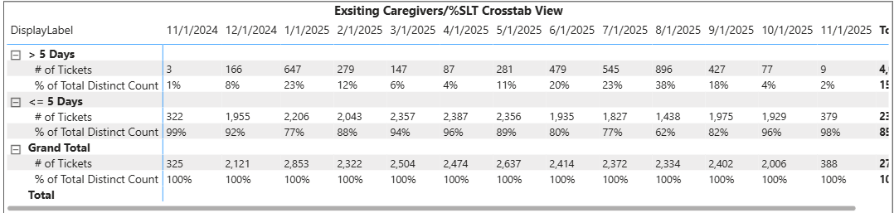
We are showcasing number of Tickets and percentage of Tickets for Existing Caregivers by SLT Days and various timelines like years, Quarters, Months, weeks, Days.
We created dynamic parameters to populate SLT Days values in rows section of matrix table.
We have created a calculated column called DisplayLabel from SLT_Matrix_Display table
We are considering the Request Area. Caregivers in the filter for this visual and selecting Existin Caregivers Onboarding
We are using ShowSLTRow measure in the filter and selecting it as 1
We are applying the Date table on this visual as filter and selecting year 2023, 2024, and 2025.
**********************************************************************************************
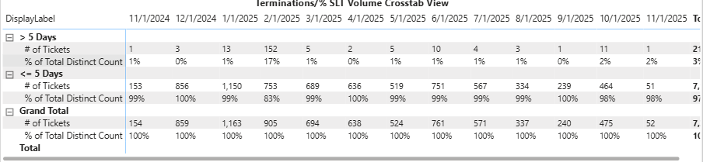
We are showcasing number of Tickets and percentage of Tickets for Terminations by SLT Days and various timelines like years, Quarters, Months, weeks, Days.
We created dynamic parameters to populate SLT Days values in rows section of matrix table.
We have created a calculated column called DisplayLabel from SLT_Matrix_Display table
We are considering the Request Area. Caregivers in the filter for this visual and selecting both Non-SailPoint Termination and SailPoint Termination.
We are using ShowSLTRow measure in the filter and selecting it as 1
We are applying the Date table on this visual as filter and selecting year 2023, 2024, and 2025.
**********************************************************************************************
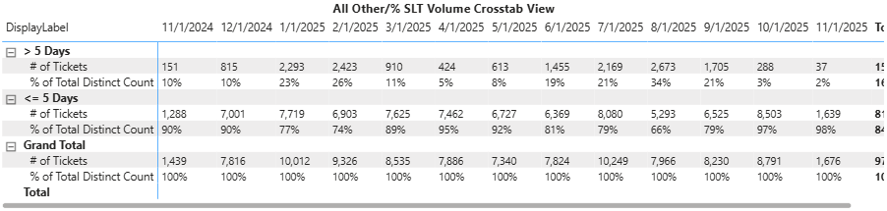
We are showcasing number of Tickets and percentage of Tickets for all other by SLT Days and various timelines like years, Quarters, Months, weeks, Days.
We created dynamic parameters to populate SLT Days values in rows section of matrix table.
We have created a calculated column called DisplayLabel from SLT_Matrix_Display table
We are considering the Request Area. Caregivers in the filter for this visual and selecting other
We are using ShowSLTRow measure in the filter and selecting it as 1
We are applying the Date table on this visual as filter and selecting year 2023, 2024, and 2025.

7. Slicers using this report:
The slicers used in the workbooks across all the pages are SLT in days, Assigned to groups, IAM Work Categories, IAM Work Queues, Workforce Type, Date, and Date Detail.
For SLT in Days refer to (9), IAM Work Queues (30), Date (13), Date Detail (17).
IAM Work Categories: It is a calucated column from the OpenServiceNow table. Below is DAX – (33)
IAM Work Categories =
IF(CONTAINSSTRING([Request Area.Detail Master],"Day One: SailPoint"), "SailPoint - Automated",
IF(OpenServiceNow[Ticket Type] = "sc_task" && CONTAINSSTRING([Request Area.Detail Master], "SailPoint"), "SailPoint - Manual",
IF( CONTAINSSTRING([Request Area.Detail Master], "Termination"), "SailPoint - Manual",
IF( CONTAINSSTRING([Request Area.Detail Master], "Epic"), "Epic",
IF( CONTAINSSTRING([Request Area.Detail Master], "Healthcare Information Exchange"), "Grant Application Access",
IF( CONTAINSSTRING([Request Area.Detail Master], "Teams"), "Collaboration",
IF( CONTAINSSTRING([Request Area.Detail Master], "Sharepoint"), "Collaboration",
IF( CONTAINSSTRING([Request Area.Detail Master], "Exchange"), "Collaboration",
IF( CONTAINSSTRING([Request Area.Detail Master], "Lync"), "Collaboration",
IF( CONTAINSSTRING([Request Area.Detail Master], "Onedrive"), "Collaboration",
IF( CONTAINSSTRING([Request Area.Detail Master], "Email"), "Collaboration",
IF( CONTAINSSTRING([Request Area.Detail Master], "Office"), "Collaboration",
IF( CONTAINSSTRING([Request Area.Detail Master], "Shared Mailbox"), "Collaboration",
IF( CONTAINSSTRING([Request Area.Detail Master], "secure mobile"), "Collaboration",
IF( CONTAINSSTRING([Request Area.Detail Master], "distribution list"), "Collaboration",
IF( CONTAINSSTRING([Request Area.Detail Master], "DL Action"), "Collaboration",
IF( CONTAINSSTRING([Request Area.Detail Master], "IS to IAM"), "Generic",
IF( CONTAINSSTRING([Request Area.Detail Master], "IS to IS"), "Generic",
IF( CONTAINSSTRING([Request Area.Detail Master], "find what I need"), "Generic",
IF( CONTAINSSTRING([Request Area.Detail Master], "Consultation"), "Generic",
IF( CONTAINSSTRING([Request Area.Detail Master], "remote"), "IDM Core",
IF( CONTAINSSTRING([Request Area.Detail Master], "Access"), "Grant Application Access",
IF( CONTAINSSTRING([Request Area.Detail Master], "Meditech"), "Grant Application Access",
IF( CONTAINSSTRING([Request Area.Detail Master], "EPCS"), "Grant Application Access",
IF( CONTAINSSTRING([Request Area.Detail Master], "Firewall"), "Grant Application Access",
IF( CONTAINSSTRING([Catalog Item Name], "Request"), "Grant Application Access",
IF( CONTAINSSTRING([Catalog Item Name], "Access"), "Grant Application Access",
IF( CONTAINSSTRING([Catalog Item Name], "find what I need"), "Grant Application Access",
IF( CONTAINSSTRING([Ticket Short Description], "Add Access"), "Grant Application Access",
IF(OpenServiceNow[Ticket Type] = "Incident", "Incident","Other"
))))))))))))))))))))))))))))))
Workforce Type: It is a calculated column which is from OpenServiceNow table. Below is DAX - (34)
Workforce Type =
IF(OpenServiceNow[Ticket Type] = "sc_task" && CONTAINSSTRING(OpenServiceNow[Ticket Short Description], "Affiliate"), "Affiliate",
IF(OpenServiceNow[Ticket Type] = "sc_task" && CONTAINSSTRING(OpenServiceNow[Ticket Short Description], "Business Partner"), "Business Partner",
IF(OpenServiceNow[Ticket Type] = "sc_task" && CONTAINSSTRING(OpenServiceNow[Ticket Short Description], "Community Connect"), "Community Technology",
IF(OpenServiceNow[Ticket Type] = "sc_task" && CONTAINSSTRING(OpenServiceNow[Ticket Short Description], "Contingent Worker"), "Contingent Worker",
IF(OpenServiceNow[Ticket Type] = "sc_task" && CONTAINSSTRING(OpenServiceNow[Ticket Short Description], "Provider"), "Provider",
IF(OpenServiceNow[Ticket Type] = "sc_task" && CONTAINSSTRING(OpenServiceNow[Ticket Short Description], "MSO"), "Provider",
IF(OpenServiceNow[Ticket Type] = "sc_task" && CONTAINSSTRING(OpenServiceNow[Ticket Short Description], "Student"), "Student",
IF(OpenServiceNow[Ticket Type] = "sc_task" && CONTAINSSTRING(OpenServiceNow[Ticket Short Description], "Vendor"), "Vendor",
IF(OpenServiceNow[Ticket Type] = "sc_task" && CONTAINSSTRING(OpenServiceNow[Ticket Short Description], "Non-Employee"), "Unknown",
IF(OpenServiceNow[Ticket Type] = "sc_task" && CONTAINSSTRING(OpenServiceNow[Ticket Short Description], "Employee"), "Employee","Unknown"))))))))))
8. Scheduled Refresh
- Refresh Schedule: Daily 6:00 AM, 12:00 PM, 6:00 PM PST
- Data Gateway Configuration: AzureBI-WestUS2Gateway-000001
9. Security & Access
- Row-Level Security (RLS):
- Roles Defined:
- Users / Groups with Access:
- Workspace Name: PHS IS IAM Security Operations - DEV
- Report Sharing Method (App / Workspace / Embedded): workspace
10. Dependencies
- Linked Reports / Dashboards:
- External Files / Scripts:
- Power Automate Flows / Alerts:
11. Change Log
Date | Changed By | Description of Change | Version
YYYY-MM-DD | Name | Added new KPI "Sales Growth" | 1.1
12. Known Issues / Limitations
- Issue Description: In tableau X - axis dates are dynamic and hierarchical with single date column. Whereas in Power BI it is not case.
- Impact: The impact in Power BI is we couldn’t see month names when we apply drill down.
- Workaround / Resolution: we created a date parameter table for dynamic axis and using date column for hierarchical axis. So, instead of showcasing month name we are showcasing month number.

